# Use Net-Zero Procurement to Win the GHG Reduction Trifecta

**Purpose**

This briefing note presents how the Government of Canada (GC) can use Net-Zero Procurement (NZP) with speed and scale to help win its GHG reduction trifecta:

1. Achieve the FSDS target of *net-zero carbon footprints of procured products* by 2050.[1]
2. Achieve the FSDS target, and the Canadian Net-Zero Emissions Accountability Act[2] requirement, to *reduce Canada’s emissions by 40–45% by 2030 and to net zero by 2050*.[3]
3. Achieve Canada’s Nationally Determined Contribution (NDC)of *reducing GHG emissions by 40-45% below 2005 levels by 2030*.[4]

**Background context**

Organizations are increasingly accountable for their direct and indirect GHG emissions. All organizations are being urged to report on and reduce their Scope 1, Scope 2, and 15 categories of Scope 3 GHG emissions (see Figure 1). To address the climate crisis, all organizations’ GHGs emissions must be reduced to net-zero by 2050 or sooner.

On average, supply chain Scope 3 emissions are 11.4 times higher than an organization’s / customer’s / purchaser’s (“buyer’s”) Scope 1 and 2 emissions.[5] The carbon footprints of purchased goods, services, and capital assets (“products”) are significant components of buyers’ Scope 3 emissions. For a buyer to achieve net-zero GHGs by 2050 or sooner, *carbon footprints of its purchased products must be net-zero by 2050* or sooner. Accordingly, the FSDS includes a target that the *GC’s procurement of goods and services will be net-zero emissions by 2050*.[6]

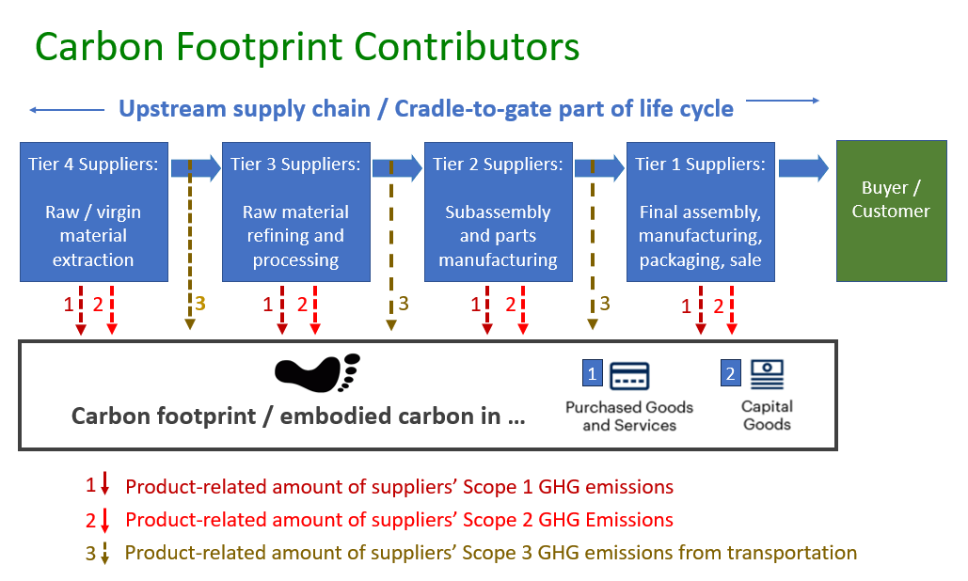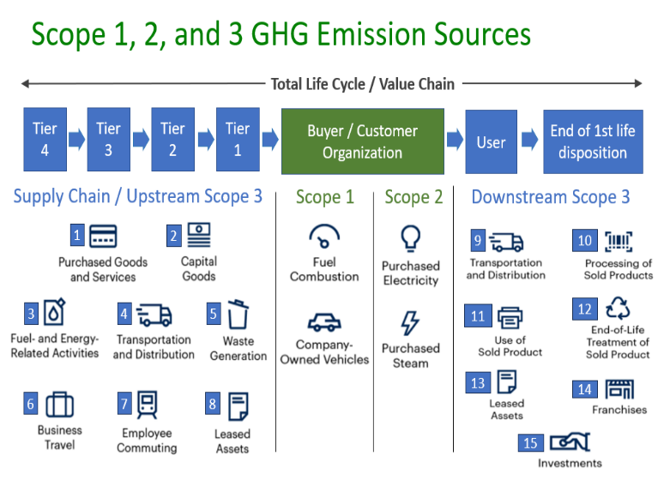Therefore, the GC seeks to purchase products with the lowest carbon footprints from providers / vendors / sellers (“suppliers”) who are the most committed to science-based GHG reduction targets (SBTs) and who are doing the most to reduce their GHG contributions to their products’ carbon footprints (see Figure 2).

Figure 1: Scope 1, 2, and 3 GHG Emission Sources Figure 2: Contributors to Product Carbon Footprints

**How Net-Zero Procurement (NZP) drives supplier GHG reductions**

Net-Zero Procurement (NZP) is defined as obtaining the best value for money when purchasing the most low-carbon goods and services *from suppliers who are most committed to science-based net-zero GHG reduction targets (SBTs).* In an NZP system, buyers use an SME-friendly supplier questionnaire (“Tool”) to score suppliers on their GHG reduction efforts. The Sustainable Purchasing Leadership Council (SPLC) encourages a three-phase “Signal - Prefer – Require” approach when embedding sustainability elements into procurement processes. The GC can use that systematic approach to integrate NZP elements into its procurement processes.

**Signal** (at *any time*, independent of tender activity)

* Explain to all suppliers why the GC needs its suppliers to reduce their products’ carbon footprints.
* Explain how the GC will use the scores from the Tool to determine the supplier’s share of the significant points allocated to supplier progress on GHG reductions in bid appraisals, from now on.
* Request that all suppliers – regardless of size, sector, or location – complete the Tool now, to provide a snapshot of the status of their efforts and provide a diagnostic on where more effort is required. The Tool gives bonus points if suppliers use NZP with *their* suppliers, launching a ripple effect of commitment to net-zero GHG reductions throughout supply chains.
* Include suppliers’ scores on the Tool in suppliers’ profiles in the Supplier Database. Suppliers can update their answers / scores at any time, including at RFx time.

**Prefer / Weight**

* + - At *tender time*, require that all bidding suppliers – regardless of size, sector, or location – respond to the Tool or update their previous response.
    - At *bid appraisal time,* significantly weight (i.e., at least 10% of the points) suppliers’ scores on the Tool. This incentivizes suppliers to do more to reduce their GHGs and their products’ carbon footprints. This is the signature feature of an NZP approach – *it motivates suppliers to reduce their GHGs to reach SBTs because they earn more points if they have a higher score, giving them a competitive advantage over other bidders.*

**Require / Contract**

* + - At *contract time*, include terms and conditions that require verification of the winning supplier’s responses to questions in the Tool, and include penalties / incentives to ensure winning suppliers follow through on their stated plans to further reduce their GHGs, as described in their Tool responses.

**How NZP helps the GC win its GHG reduction trifecta**

Canada’s 2030 Emissions Reduction Plan (ERP)[7] has excellent actions that drive significant GHG emission reductions. A robust NZP system complements those measures and helps the GC win its GHG reduction trifecta.

1. **Achieve the FSDS target of *net-zero carbon footprints of procured products* by 2050.**NZP incentivizes suppliers throughout the GC’s supply chains to reduce their Scope 1, Scope 2, and relevant Scope 3 GHG emissions to net-zero by 2050 or sooner. If GC suppliers’ GHG emissions are net-zero, their products’ carbon footprints are net-zero (see Figure 2).
2. **Achieve the FSDS target, and the Canadian Net-Zero Emissions Accountability Act requirement, to *reduce Canada’s emissions by 40– 45% by 2030 and to net zero by 2050*.**If NZP and the Tool were packaged by the GC and deployed with speed and scale by all levels of government in Canada, it would unleash over $200 billion of buying power in the race to net-zero. This market force would drive the targeted GHG reductions in a critical mass of Canadian businesses by 2030 and 2050.
3. **Achieve Canada’s NDC of *reducing GHG emissions by 40-45% below 2005 levels by 2030****.*   
   Achieving #2 above also achieves the GC’s NDC, enhancing Canada’s reputation on the international stage. Further, if Canada led the effort to have its NZP system used by all 197 countries attending the next COP, that would unlock over $9 trillion of buying power to engage suppliers worldwide in the drive to net zero, in time.

1. “[Federal Sustainable Development Strategy (FSDS) 2022 to 2026](https://www.canada.ca/en/environment-climate-change/services/climate-change/federal-sustainable-development-strategy.html),” Government of Canada, 2022, p, 146.
2. “[Canadian Net-Zero Emissions Accountability Act](https://www.canada.ca/en/services/environment/weather/climatechange/climate-plan/net-zero-emissions-2050/canadian-net-zero-emissions-accountability-act.html),” Government of Canada, 2022.
3. “[Federal Sustainable Development Strategy (FSDS) 2022 to 2026](https://www.canada.ca/en/environment-climate-change/services/climate-change/federal-sustainable-development-strategy.html),” Government of Canada, 2022, p, 155.
4. “[Canada’s 2021 Nationally Determined Contribution](https://unfccc.int/sites/default/files/NDC/2022-06/Canada%27s%20Enhanced%20NDC%20Submission1_FINAL%20EN.pdf),” UNFCC, 2022.
5. "[Global Supply Chain Report 2022](https://cdn.cdp.net/cdp-production/cms/reports/documents/000/006/918/original/CDP-Supply-Chain-Report-2022.pdf)," CDP, March 2023.
6. “[Federal Sustainable Development Strategy (FSDS) 2022 to 2026](https://www.canada.ca/en/environment-climate-change/services/climate-change/federal-sustainable-development-strategy.html),” Government of Canada, 2022, p, 146.
7. “[2030 Emissions Reduction Plan](https://www.canada.ca/en/services/environment/weather/climatechange/climate-plan/climate-plan-overview/emissions-reduction-2030.html)”, Government of Canada, March 2022.